NOTICE OF PUBLIC MEETING

Laclede Water District
208-255-4068
Meeting Date January 15, 2025 at Laclede Community Center – 6:00pm

Those in attendance were Kimberly Swank, Dave Stevens, Gloria Fletcher, Bob Hansen, Vicky Johnson, Linda and Jim Vandeweg.

Bring meeting to order*
Dave brought the meeting to order at 6:02.

Approve Minutes
Dave asked if anyone wanted the minutes to be read. No one did. Kimberly made a motion to approve the minutes, Gloria 2nd it and they were approved.

Changes in Agenda *
No one had any.

Budget Review and Comments*
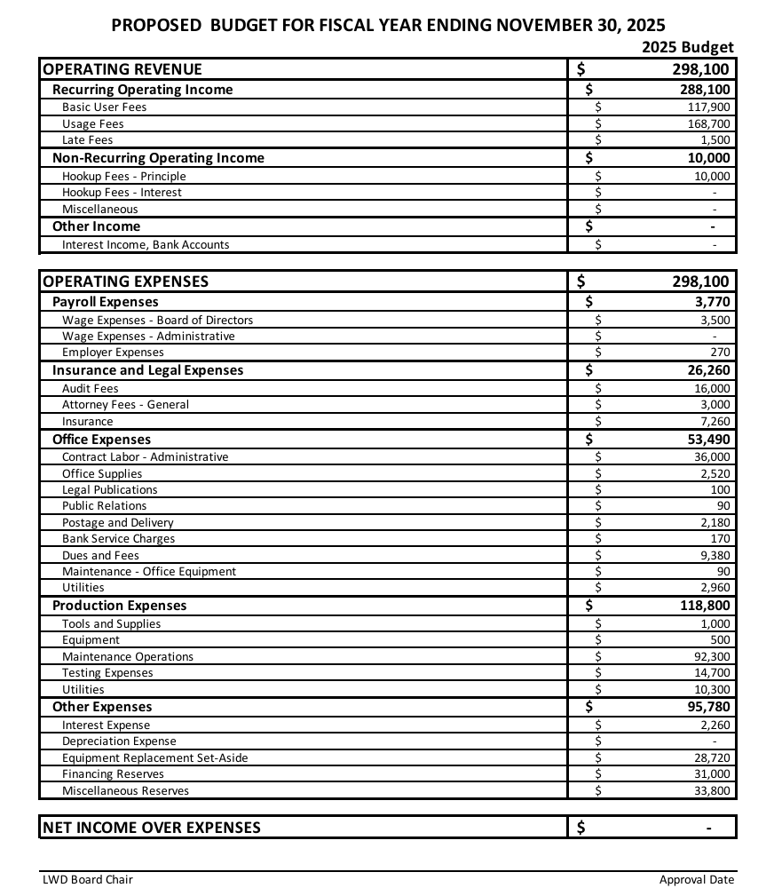

Dave talked about the budget to the water users that were present. The budget was announced in the paper. Dave asked for approval of the 2025 budget that ends in November 2025. Gloria made a motion to accept the 2025 budget, Kimberly seconded it, and it was approved.

Old Business*
Update from Ardurra *
We didn’t get anything from Brent for the meeting.
Our users wanted to know more about what was happening with the upgrade.
Dave gave an update to the three people who were at the meeting. He explained the process and the bidding that was just done.
He also read last month’s report from Ardurra and let them know what is next.

Ordinances/By-Laws * (Tabled to the end of the meeting)
Dave explained what we had done with the Ordinances to the people at the meeting. He had seven items that we had left to discuss from the last meeting.

Update from Bank on Signatures
Gloria read the emails from the bank. They are being quite difficult to get this changed. We discussed moving the checking account to a different bank. Gloria will send “another” email to Melissa the bank manager and see what happens.

New Business*
We had no new business.

Plant Operation*
Bob gave the usage report for us to review. We talked about the water leak on the Glazier’s property. Mike and Kendall worked till very late and again the next day to repair it.
Bob also told us that the DEQ sent new requests on chemicals they want to know about. Apparently, we had a lot of testing that had been waivered and now is coming due. He told us the different chemicals that need to be tested for. Some take a while to get the results. We have from July 1st to October 1st to get some samples. This needs to be done by the end of the year.. Bob explained to our Users a bit about the new plant and what type of plant it will be.

Water User Forum
Our Users asked questions all through the meeting so didn’t have any more questions.

Treasurer’s Report *
Umpqua Checking - Stephanie didn’t give a report.
Umpqua Reserve Acct - Stephanie didn’t give a report.
Mountain West Flex account - Stephanie didn’t give a report.

Accounts that are delinquent
Stephanie didn’t give a report.

Review/Pay the bills *
Gloria made a motion to pay the bills and Kimberly seconded it. It was approved.

Ordinances/By-Laws * (Tabled to the end of the meeting)
Dave brought up the items we needed to review from the last meeting.

- Financial obligations for installation fee needed to be paid in full. Dave read the by-law. The question is if we want to offer a finance plan for people putting in a connection. We discussed that since we are a small “village” maybe we wanted to continue. Dave looked up that we have been financing. The other question that Chuck had is if we have ever been stiffed for not paying it back. The answer was no. It was decided that since we have already been doing it, we should continue to do it.
2-3 What does the service connection cover? We talked about the $10,000 to see if it is the right number. Ardurra did a benchmark for us and it was $8300. They apparently thought it was the equity in the system. And the cost of installation was separate. We decided we needed to figure out what the connection fee includes. If we look at the cost of the recent installations we thought the $10,000 includes the installation fee. We talked that we had never heard of “buying” into the system.
4. How the Board runs. Dave said one thing missing is removal by cause of a Board Member. A lot of effort “outside” a meeting is done by the Board members. Right now a Board member only gets their stipend if they attend the meeting. Discussion on the amount of time is spent for a Board member. We decided that Board members should get paid even if they don’t attend a meeting. We should have a removal of cause put in too.
5. In paragraph 5.3 and 5.4 was a circular meeting. Meetings need to be posted in one of two places, at the Post Office and the web site. We can have more but not less for public notices.
6. 7.2.1 moved the billing in appendix. We wanted to have it somewhere it can be changed easily. That way the Ordinance can be staple and adopted by resolution.
7. Directors compensation. Right now each director gets $50 a month to attend a meeting. It hadn’t changed since 2013 version. Dave proposes that the payment number not in excess of the 2013 number to the CPI (inflation calculator) number would $65.00. When the CPI goes up it can be adjusted yearly. Some questions from our guests came on this change. We decided to add this to the document.

Adjournment
Gloria made a motion to adjourn, Dave 2nd it. Approved. The meeting was adjourned at 7:44.

*Action items

